FRAME AND ELECTRONICS ASSEMBLY

1. Start with sticking the motors onto the bottom plate of the chassis with the foam tape provided.
2. Assemble the top plate with the bottom plate with the provided clips and draw the motor leads out through the two holes as shown in the picture.
3. Stick the breadboard onto the top of the bot with the foam tape/velcro provided. The breadboard has voltage regulators, motor driver and two resistors already present.
4. Connect the left motor leads to A01 and A02 and the right motor leads to BO1 and BO2 on the motor driver. Similarly, connect Vmot and GND to the voltage regulator output.

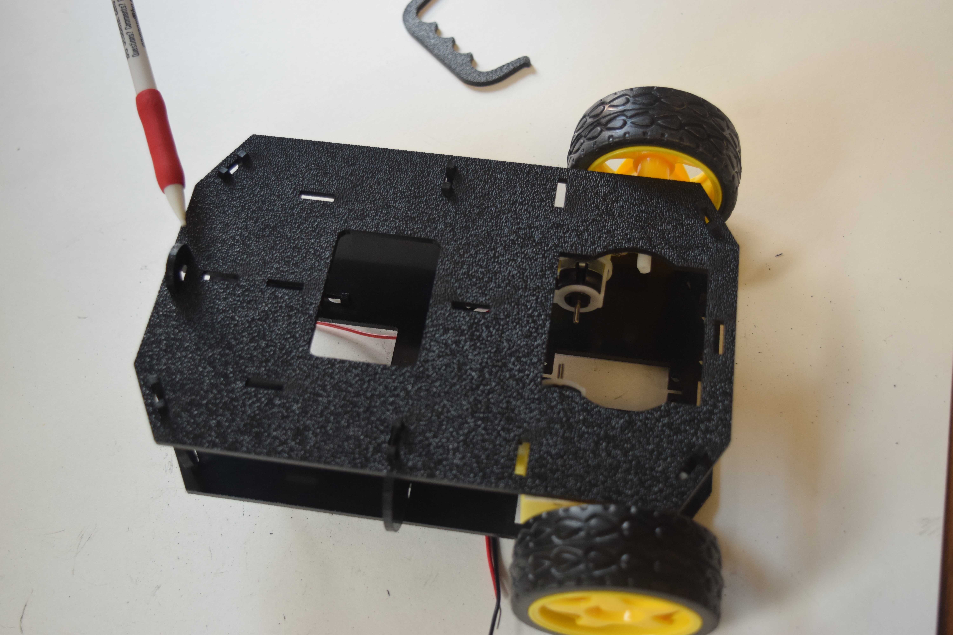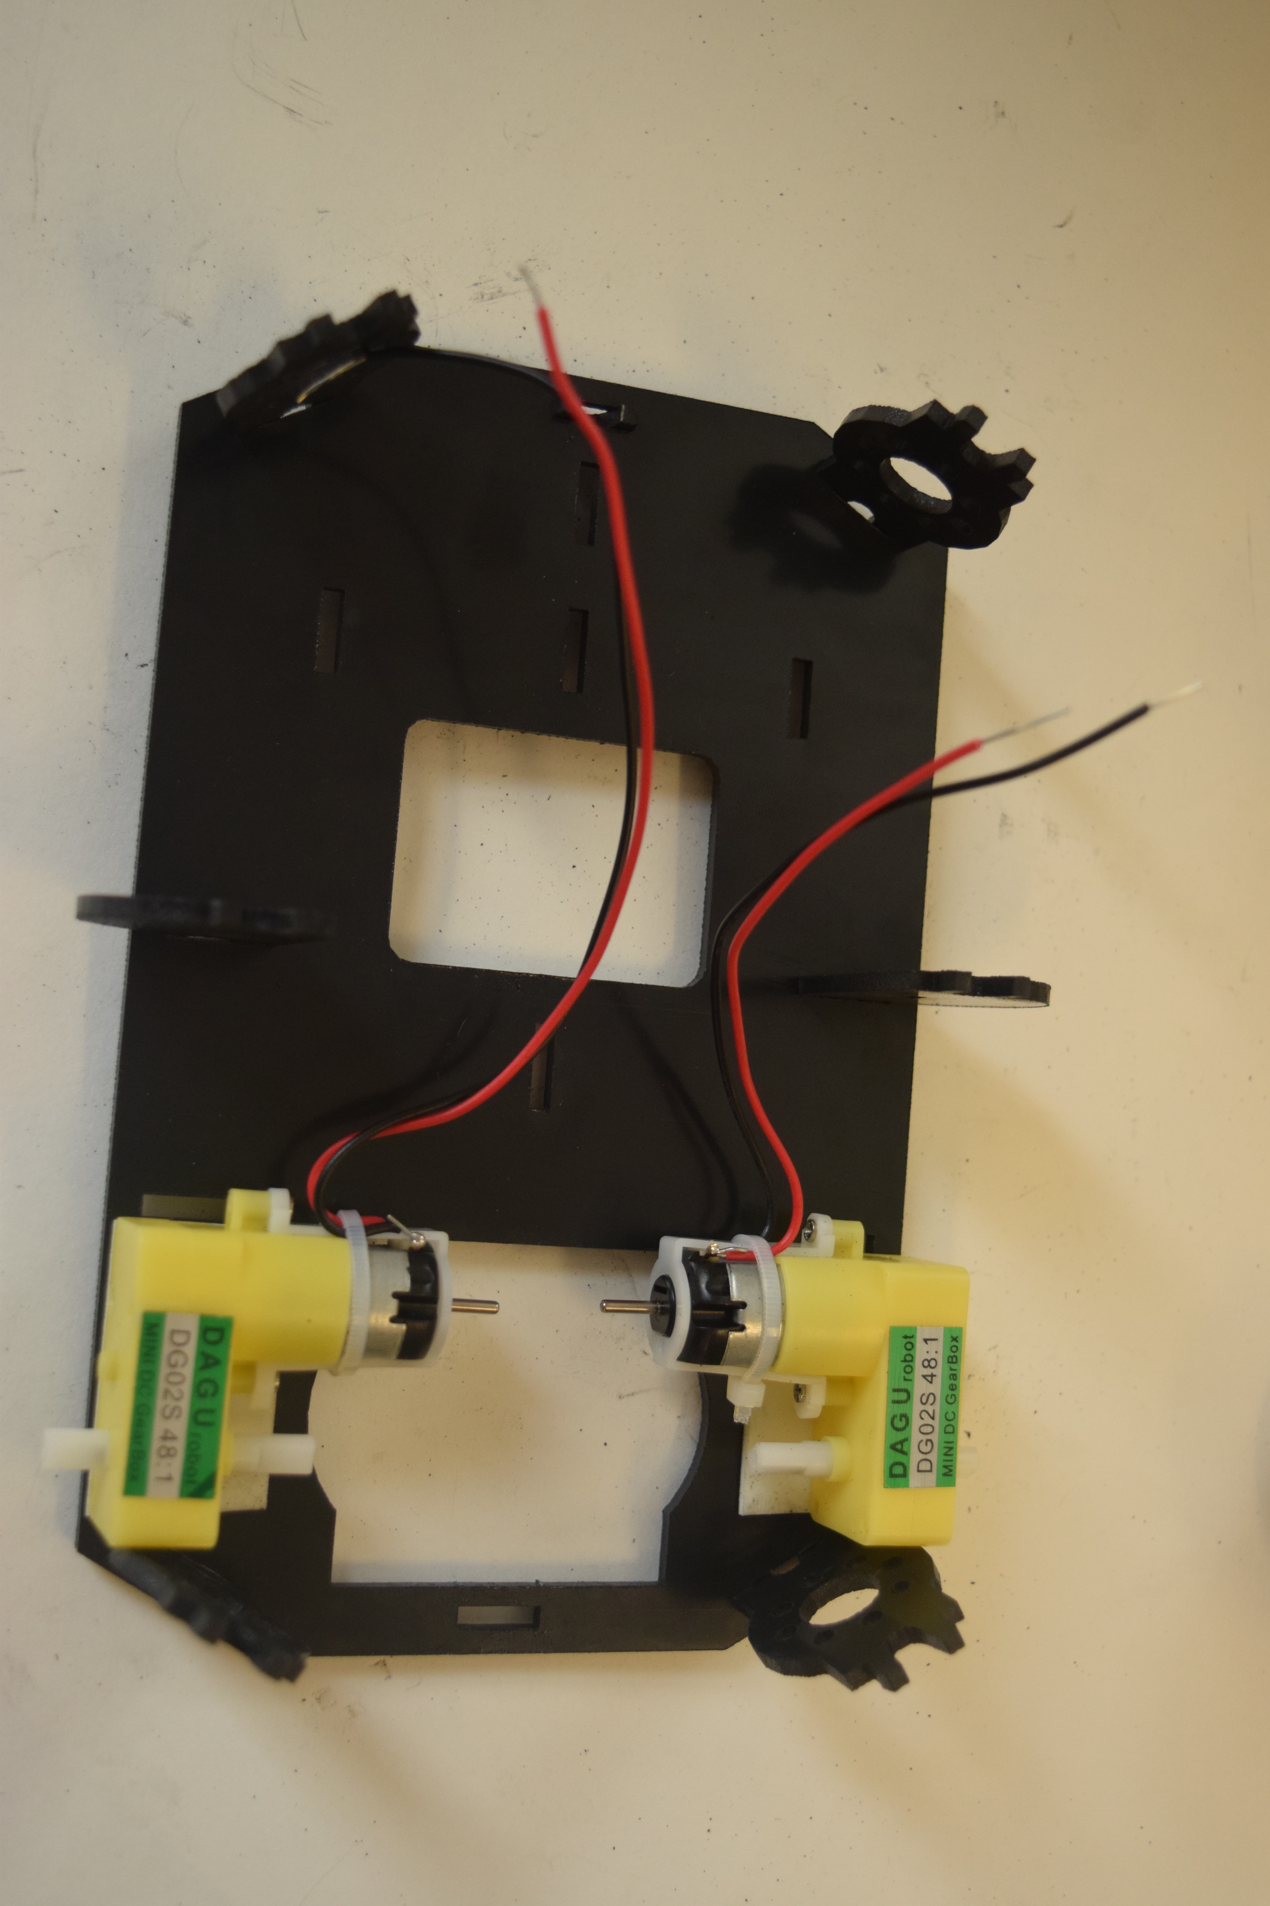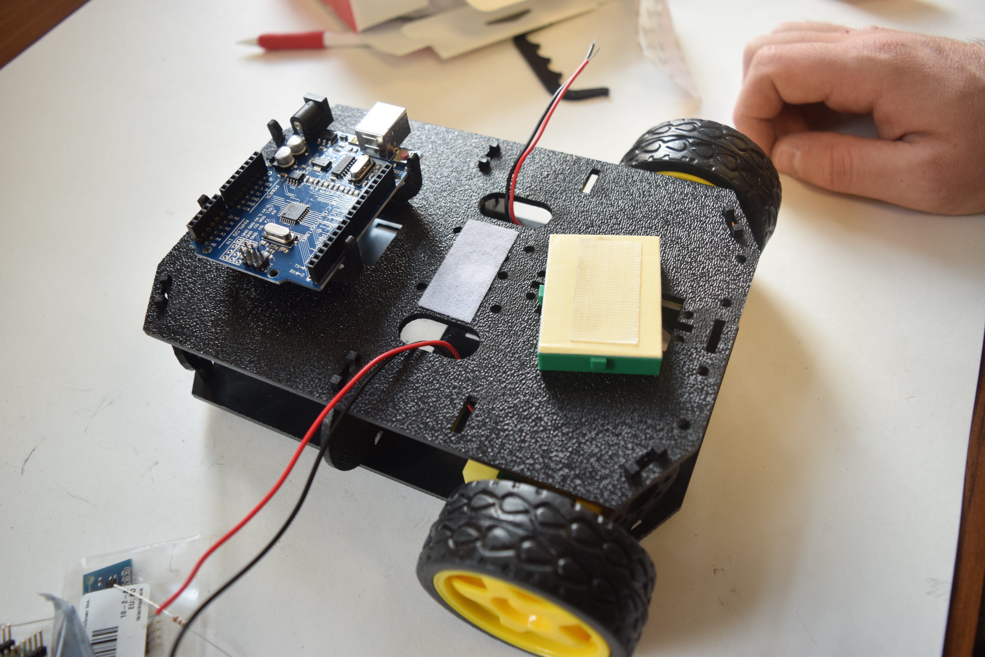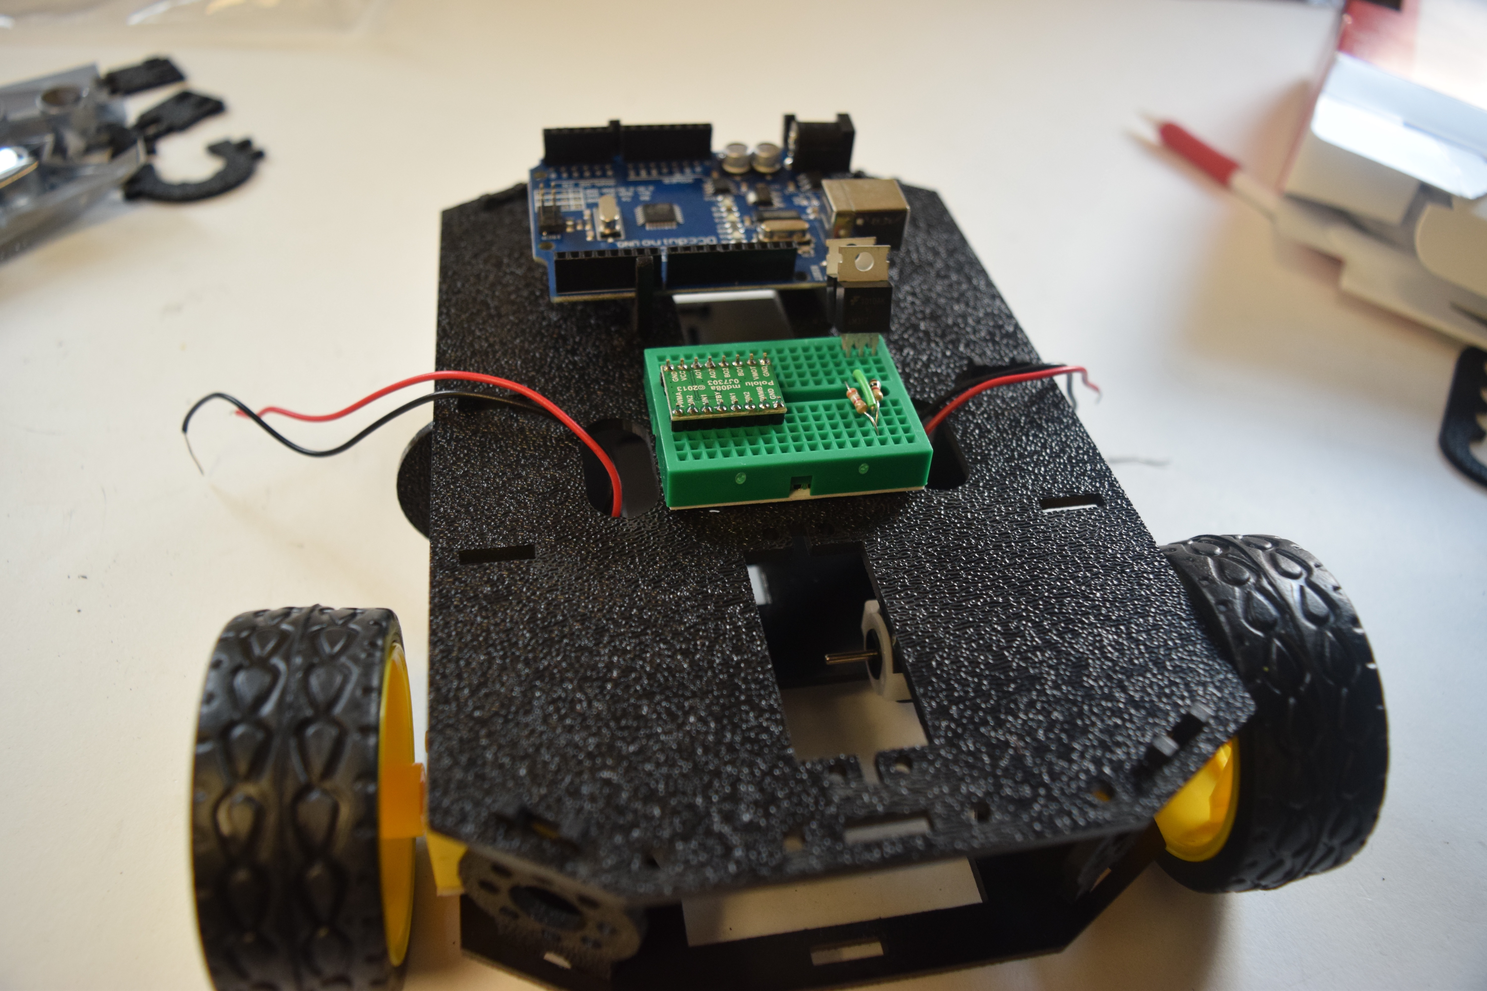

1. Also connect PWMA, AIN1, AIN2 to pins 6, 4, 5 respectively and pins PWMB, BIN1, BIN2 to pins 9, 7 and 3 on the Arduino respectively.
2. Connect STBY pin to Vcc (5V) on the Arduino.

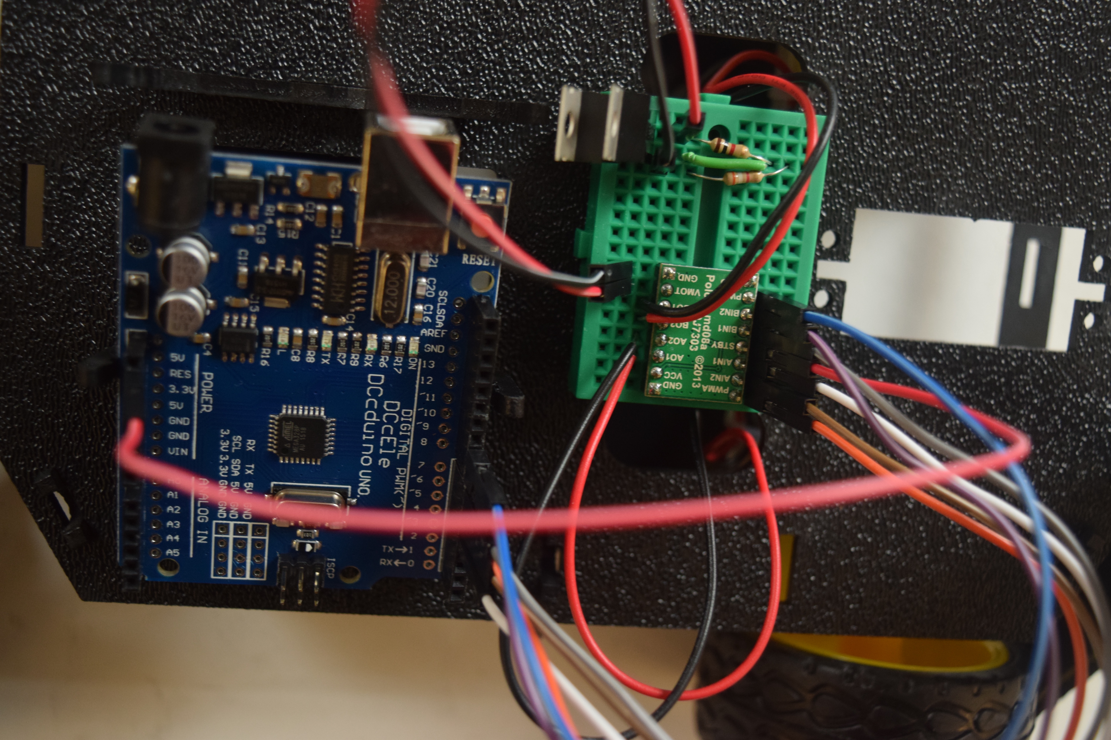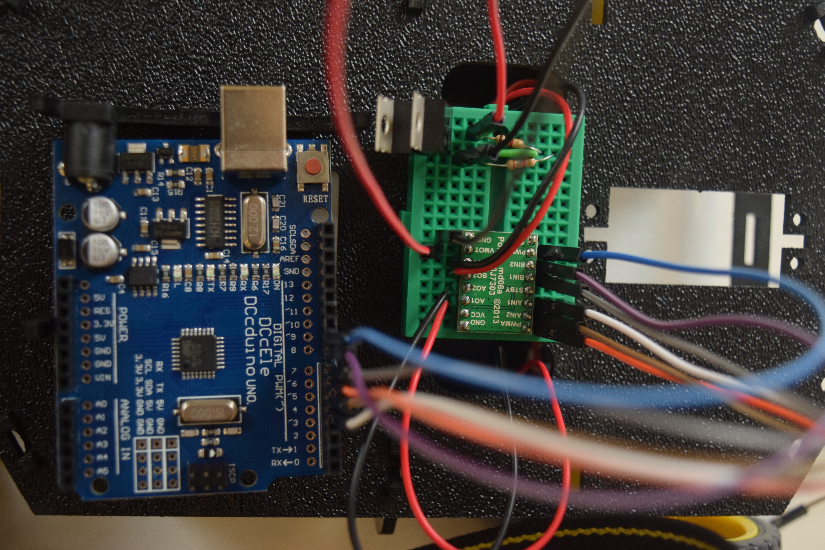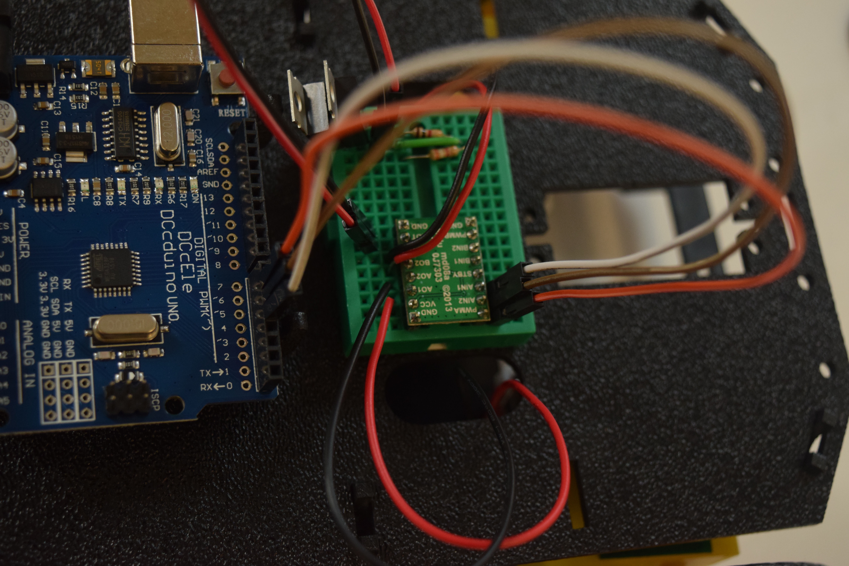

1. Connect the ultrasonic sensor pins VCC and GND to 5V and GND on the Arduino. Connect the TRIG and ECHO pins to Arduino pins 8 and 9.
2. Connect the IR line follower sensor pins Out1, Out 2, and Out 3 to pins A2, A0 and A1 respectively and the VCC and GND pins to 5V and GND on the Arduino.
3. Connect the battery leads +V to VIN of the voltage regulator and GND to the pin adjacent to the Vadjust terminal of the voltage regulator.
4. Attach the plastic plate to the front of the bot with foam tape and stick the IR sensor to the bottom of the plate facing down. Make sure it is rigid and parallel to the floor (the sensor is very sensitive to angular changes after initialization).

